Given an integer numRows, return the first numRows of **Pascal's triangle**.

In **Pascal's triangle**, each number is the sum of the two numbers directly above it as shown:



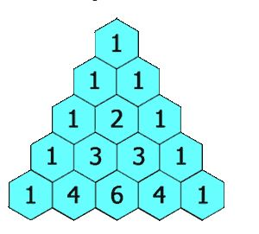

**Example 1:**

**Input:** numRows = 5

**Output:** [[1],[1,1],[1,2,1],[1,3,3,1],[1,4,6,4,1]]

**Example 2:**

**Input:** numRows = 1

**Output:** [[1]]

**Constraints:**

* 1 <= numRows <= 30